

Internship Report

on

**CARSE-CHALO: A REACT-BASED TRAVEL AND TRANSPORTATION SERVICE WEBSITE**

A report submitted in partial fulfilment of the requirements for the Award of Degree of

BACHELOR OF TECHNOLOGY

in

COMPUTER SCIENCE AND ENGINEERING

by

Sahil Thakur Enrolment No. – A25305222050

Under the Guidance of

Mrs. Prerna Kamat (Industry Project Supervisor)

(Team Leader)

AMITY SCHOOL OF ENGINEERING AND TECHNOLOGY

Amity University Punjab

Mohali – **140306**

2024-25

**Certificate**

**DECLARATION**

I, Sahil Thakur, student of B.Tech in Computer Science & Engineering at Amity University Punjab, hereby declare that the internship work entitled **"CarSe-Chalo"** has been carried out independently by me under the supervision of **Mrs. Prerna Kamat, Celebal Technologies**. This report is submitted in partial fulfilment of the requirements for the award of the degree of **Bachelor of Technology in Computer Science & Engineering** of Amity University Punjab for the academic year 2025-26.

I further declare that this report is my original work and has not been submitted to any other university or institution for the award of any degree or diploma.

Date: **Name and Signature of Student**

Place:

**ACKNOWLEDGEMENT**

First and foremost, we would like to express our heartfelt gratitude to our parents. Their unwavering support, hard work, and sacrifices have laid the foundation for our achievements and brought us to this stage of our academic journey.

We extend our sincere thanks to **Mrs. Prerna Kamat,** for providing us with the necessary facilities, resources, and guidance that greatly contributed to the successful and timely completion of our internship.

We are deeply grateful to our supervisor, **Mrs. Prerna Kamat, Team Leader, Celebal Technologies,** for standing by us throughout the internship period. Their valuable insights, encouragement, and continuous support played a pivotal role at every step of our work.

We also express our gratitude to Dr. Himanshu Jindal, Head of the Department, Amity School of Engineering and Technology, for his consistent support and encouragement.

We remain indebted to Dr. Shashi Bhushan, Head of School, for his mentorship and motivation throughout our academic tenure.

We sincerely thank Dr. Rajni Mohana for her constant guidance and valuable suggestions that helped us improve and move forward with confidence.

Finally, we wish to acknowledge all the teaching and non-teaching staff of the Amity School of Engineering and Technology for their kind cooperation, help, and support throughout the course of this internship.

**Name and signature of Students**

**ABSTRACT**

The project titled **“CarSe-Chalo”** is a comprehensive full-stack web-based travel and transportation service platform developed as part of an academic internship. The core objective of the project is to create a scalable and user-friendly digital solution that enables users to book car rentals, explore curated travel packages, and plan adventure tours across a variety of popular destinations. The platform is designed with an emphasis on intuitive user experience, efficient navigation, and responsive design, catering to both desktop and mobile users.

The frontend of the application is built using **React with TypeScript**, powered by **Vite** for fast build performance and **Tailwind CSS** for utility-first styling. **React Router** handles seamless page navigation while **Framer Motion** enriches the interface with modern animations. Key UI components include secure user authentication, dynamic destination search with auto-suggestions, a shopping cart system with persistent state (via Local-Storage), and an interactive interface that highlights tour packages and service offerings.

As part of its backend design, the project is structured for future integration with server-side APIs, user databases, and admin dashboards—qualifying it as a full-stack solution. While this phase primarily focused on frontend implementation, the project is built with extendable architecture ready for backend modules such as booking history, payment integration, and real-time data syncing through RESTful services.

A standout feature of the project is the development and integration of a **self-trained AI chatbot**. This conversational assistant is designed to help users interact with the system naturally, addressing queries related to tour packages, navigation, and services. Trained on travel-related FAQs and user behaviour patterns, the chatbot enhances the platform’s accessibility and engagement, simulating intelligent responses based on user input.

The project followed an agile development methodology, organized into structured weekly sprints to iteratively design, develop, and test individual modules. Key challenges included managing responsive layout transitions, synchronizing persistent UI states, and optimizing user flow between modules. These challenges offered valuable learning opportunities and contributed significantly to the developer's understanding of real-world problem-solving in web development.

In conclusion, **CarSe-Chalo** represents a well-architected full-stack project prototype that demonstrates practical skills in frontend engineering, backend extensibility planning, and intelligent user assistance. The experience gained through this project has reinforced technical skills, enhanced understanding of modern development stacks, and provided a strong foundation for building scalable web applications in the future.

**TABLE OF CONTENTS**

|  |  |  |  |
| --- | --- | --- | --- |
| **Chapter** |  | **Title** | **Page No.** |
|  |  | CERTIFICATE  DECLARATION  ACKNOWLEDGEMENT | i  ii  iii |
|  |  | ABSTRACT  TABLE OF CONTENTS | iv  v |
|  |  | LIST OF FIGURES | vi |
|  |  | LIST OF TABLES | vii |
|  |  |  |  |
| **Chapter** | **1** | **Company Profile** | **01-xx** |
|  | 1.1 | History of Organization | 01 |
|  | 1.2 | Operations of the Organization | 01 |
|  | 1.3 | Major Milestones | 03 |
|  | 1.4 | Structure of the organization |  |
|  |  |  |  |
| **Chapter** | **2** | **Work Undertaken** | **xx-xx** |
|  | 2.1  2.2  2.3  2.4 | Role in Company  Department/Team allocated  Tools and Technologies learnt  Skills Acquired |  |
| **Chapter** | **3** | **Project -Carried out** | **14-21** |
|  | 3.1  3.2  3.3.  3.4  3.5  3.6  3.7  3.8  3.9  3.10  3.11  3.12 | Introduction  Project Title  Objective(s) of the Project  Problem Statement  Rationale: Justification, why is this project needed?  Tools and Technologies Used  System Architecture / Flow Diagrams  Implementation Details  Sample Outputs / Screenshots  Challenges Faced and Solutions  Contribution to the Organization  Future Scope of the Project |  |
| **Chapter** | **4** | **Learning Outcome(s)** |  |
|  | 4.1  4.2  4.3  4.4 | Technical Skills Gained  Soft Skills Gained  Industry Exposure  Gaps Identified in Knowledge |  |
| **Chapter** | **5** | **Conclusion** | **22-26** |
|  |  | **References** |  |

**LIST OF FIGURES**

|  |  |  |  |
| --- | --- | --- | --- |
| **Figure** | **No.** | **Title** | **Page No.** |
| Figure | 1.1 |  | 02 |
| Figure | 1.2 |  | 04 |
| Figure | 1.3 |  | 05 |
| Figure | 2.1 |  | 05 |
| Figure | 2.2 |  | 06 |
| Figure | 3.1 |  | 19 |
| Figure | 3.2 |  | 19 |
| Figure | 3.3 |  | 20 |
| Figure | 4.1 |  | 23 |

**LIST OF TABLES**

|  |  |  |  |
| --- | --- | --- | --- |
| **Table** | **No.** | **Title** | **Page No.** |
| Table | 3.1 | List of tools and technologies used in this project | 04 |
| Table | 3.2 | Challenges faced during development and solution to each problem | 09 |

**CHAPTER 1**

**THE ORGANIZATION – CELEBAL TECHNOLOGIES**

* 1. **History of the Organisation**

Celebal Technologies was founded in 2015–2016 in Jaipur, India, by Anirudh Kala and Anupam Gupta. Initially beginning as a data analytics startup, it has rapidly evolved into a global technology services firm focused on digital transformation, AI, and enterprise cloud innovation.

* 1. **Operations of the Organization**

Celebal Technologies delivers enterprise-grade solutions in Generative AI, Machine Learning, Data Science, Cloud Migration, Application Modernization, SAP Innovation, Infrastructure Upgrade, and Chatbots. The company serves large enterprises across industries including Manufacturing, Financial Services, Retail, Healthcare, Media & Entertainment, and Education. Celebal has developed strategic partnerships with technology leaders such as Microsoft, Databricks, AWS, and SAP.

With a workforce of over 2,000‑3,000 certified professionals, the company maintains offices globally in India, USA, Canada, UK, UAE, Australia, Singapore, and Japan.

* 1. **Major Milestones**

1. Won Microsoft India Partner of the Year award in 2021 (first company in Rajasthan to achieve this) and retained the title in 2022, followed by Microsoft AI Partner of the Year in 2023.
2. Received Databricks APJ Partner of the Year awards multiple times and a strategic investment from Databricks Ventures in September 2023.
3. Secured major funding rounds: $32M in Series A (Nov 2022), followed by $14.7M in Series B led by InCred Growth Partners in May 2025, doubling its valuation to approximately $211M (~₹1,795 Cr).
   1. **Structure of the Organization**

As a mid-to-large scale enterprise, Celebal is structured with core leadership (co‑founders and executive team), departmental heads overseeing domains like AI, Cloud & Infrastructure, Data Engineering, and Client Delivery. It also includes global delivery centers and centers of excellence spread across continents. Its partnerships with Microsoft, Databricks, SAP, and Red Hat bolster its organizational structure around technology alliances and seamless service delivery.

**CHAPTER 2**

**WORK UNDERTAKEN**

* 1. **Role in Company**

During my internship at Celebal Technologies, I was assigned the role of a Full Stack- Developer Intern with a focus on user interface development, design implementation, and responsive layout creation. My key responsibility was to independently conceptualize and build a modern travel service platform named CarSe-Chalo, which integrates features like user login, real-time search, interactive UI, and shopping cart functionality.

* 1. **Department / Team Allocated**

I worked under the UI/UX Engineering and Web Application Development team. Though the project was primarily self-led, I received mentorship and guidance from technical leads within the frontend division. This experience provided valuable exposure to industry-standard practices in full-stack design and web deployment architecture.

* 1. **Tools and Technologies Learnt**

Throughout the internship, I gained hands-on experience with the following modern technologies and development tools:

1. React (with TypeScript) – for component-based web UI architecture
2. Tailwind CSS – for utility-first responsive styling
3. Vite – for faster development and build processes
4. React Router DOM – for navigation and routing
5. Framer Motion – for animations and transitions
6. Local-Storage – for state persistence on client-side
7. Visual Studio Code (VS Code) – as the primary IDE
8. Git & GitHub – for version control and code collaboration
9. Postman (explored) – for API simulation and testing
   1. **Skills Acquired**

The internship helped me develop and refine the following technical and professional skills:

1. Designing responsive, animated frontends for real-world web applications
2. Building and managing component hierarchies and props/state flow in React
3. Implementing user authentication flows using local storage
4. Creating dynamic user interfaces such as search bars, carousels, and side menus
5. Applying Agile principles with weekly targets and task reviews
6. Problem-solving for UI bugs, data persistence, and performance bottlenecks
7. Collaborating with documentation best practices for handover and scaling.

**CHAPTER 3**

**PROJECT – CARSE-CHALO**

* 1. **Introduction**

The project titled “CarSe-Chalo” is a feature-rich, scalable web-based application developed during my internship tenure at Celebal Technologies. The project focuses on streamlining the user journey for discovering travel destinations, renting vehicles, and booking travel packages—all from a single platform. It is designed to serve as a model for digital transformation in the travel and transportation sector. With a frontend-first architecture and backend extensibility, the project also reflects the principles of full-stack application design. The platform incorporates a modular UI, seamless routing, persistent state management, and an AI-enabled chatbot for enhanced user interaction.

* 1. **Project Title**

**CarSe-Chalo – Unified Travel and Transportation Web Service Platform**

* 1. **Objective(s) of the Project**

1. To develop an intuitive and interactive web platform where users can plan trips, rent cars, and book travel experiences in a single session.
2. To ensure that the application is responsive, easy to navigate, and visually appealing.
3. To use modern frontend tools like React, Tailwind CSS, Vite, and Framer Motion to build reusable, scalable components.
4. To implement a Trained AI chatbot that can assist users in real-time with package discovery and basic queries.
5. To simulate a full-stack setup with frontend logic ready for backend APIs, payment gateways, and database integration.
   1. **Problem Statement**

The travel industry often lacks platforms that offer a cohesive experience. Users must typically rely on multiple websites or apps to book transportation, explore destinations, and organize their travel packages—leading to fragmented experiences. Moreover, many platforms are either outdated in design or lack interactivity. There is a need for a comprehensive, responsive, and intelligent web application that consolidates these services while maintaining usability and performance.

* 1. **Rationale: Why is this Project Needed?**

With the boom in domestic tourism, especially in hill stations and spiritual retreats across India, there is a rising demand for tech-enabled travel platforms that can handle everything—from pickups to package planning. CarSe-Chalo addresses this need by providing an easy-to-use, centralized web interface for booking car rentals, browsing packages, and interacting with an AI assistant for travel support. It is particularly useful for new-age travellers seeking quick decision-making, convenience, and real-time assistance.

* 1. **Tools and Technologies Used**

|  |  |
| --- | --- |
| **Tool/Technology** | **Purpose** |
| React with TypeScript | Core UI development and component structure |
| Vite | Fast development and build tooling |
| Tailwind CSS | Utility-first styling and responsive design |
| React Router DOM | Route management and page transitions |
| Framer Motion | Adding smooth animations and user interaction transitions |
| Local-Storage | Data persistence across sessions for cart and login |
| Git & GitHub | Version control and collaborative code management |
| VS Code | Development environment and extensions for code linting |

*Table – 3.1 (List of tools and technologies used in this project)*

* 1. **System Architecture**

The architecture is component-based and follows a modular pattern where each feature (like authentication, search, cart) is separated into reusable units. Major flows include:

1. Authentication Flow – Handling login/register using browser Local-Storage.
2. Search & Navigation Flow – Dynamic filtering of services and destinations
3. Cart Management Flow – Persistent cart functionality with local data storage
4. Chatbot Interaction Flow – Message-trigger based reply system using trained data
5. User Journey Flow – From homepage → search → details → cart → checkout

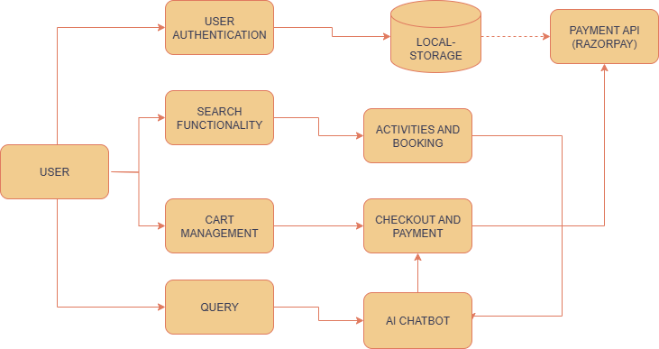

*Fig – 3.1 (System Architecture)*

**USE CASE DIAGRAM**

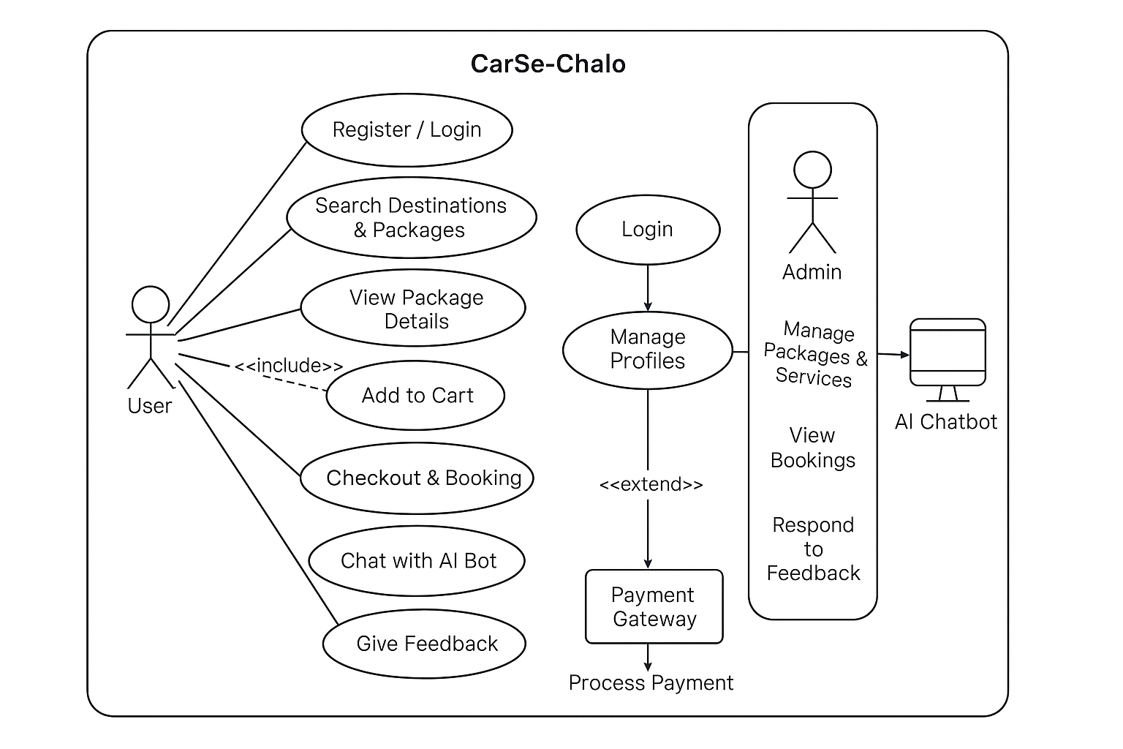

*Fig – 3.2 (Use Case Diagram)*

* 1. **Implementation Details**

1. Developed a fully responsive landing page with carousels showcasing destinations like Ladakh, Goa, Palampur, etc.
2. Built a secure authentication system using React state and Local-Storage for login/session management.
3. Designed an auto-suggest search bar that filters destinations and services in real time.
4. Integrated a cart module allowing users to add packages and retain them across sessions.
5. Created interactive UI cards for travel packages with pricing, destination details, and quick add-to-cart options.
6. Incorporated a self-trained AI chatbot built using a logic-based rule engine trained on FAQs to guide user queries.
7. Applied Framer Motion to add animations during component load, navigation transitions, and hover effects.
8. Ensured cross-device responsiveness using Tailwind’s responsive classes and tested it on multiple screen sizes.
   1. **Sample Outputs / Screenshots**
9. Home page with Destination Carousel

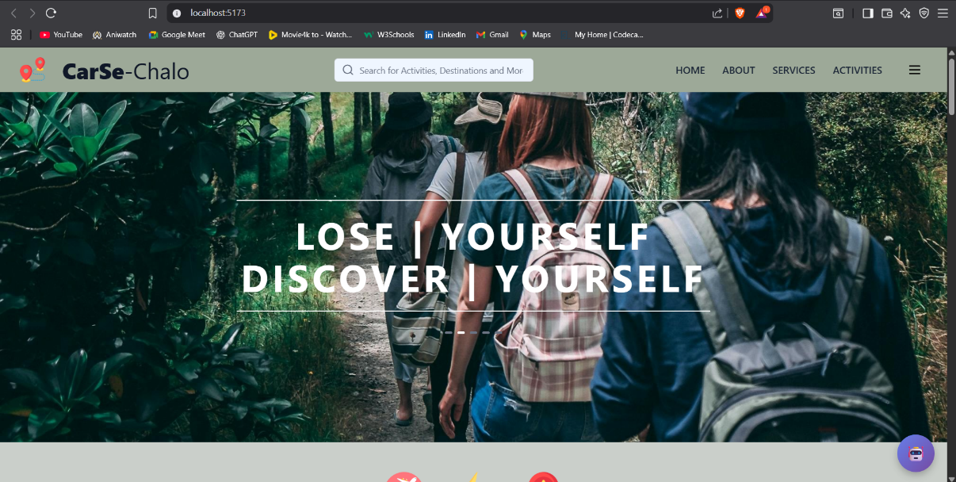

*Fig - 3.3 (Home page with all features and navbar links with a proper   
search functionality)*

1. Login/Register Page



*Fig – 3.4 (Login and Register page authenticated with firebase authentication service)*

1. Package Cards

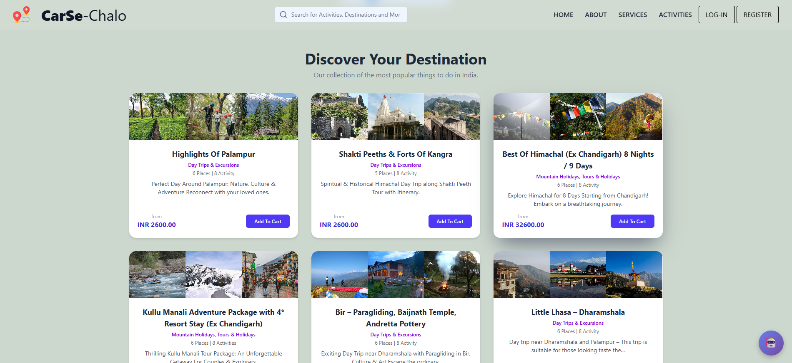

*Fig – 3.5 (Browse through travel packages and chose your preferred package)*

1. Package Cart Page

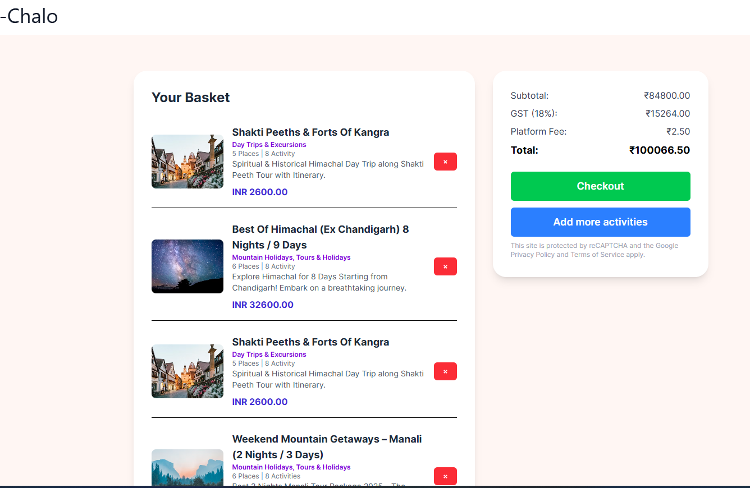

*Fig – 3.6 (Cart option to give a final checkup on the package)*

1. Payment Gateway

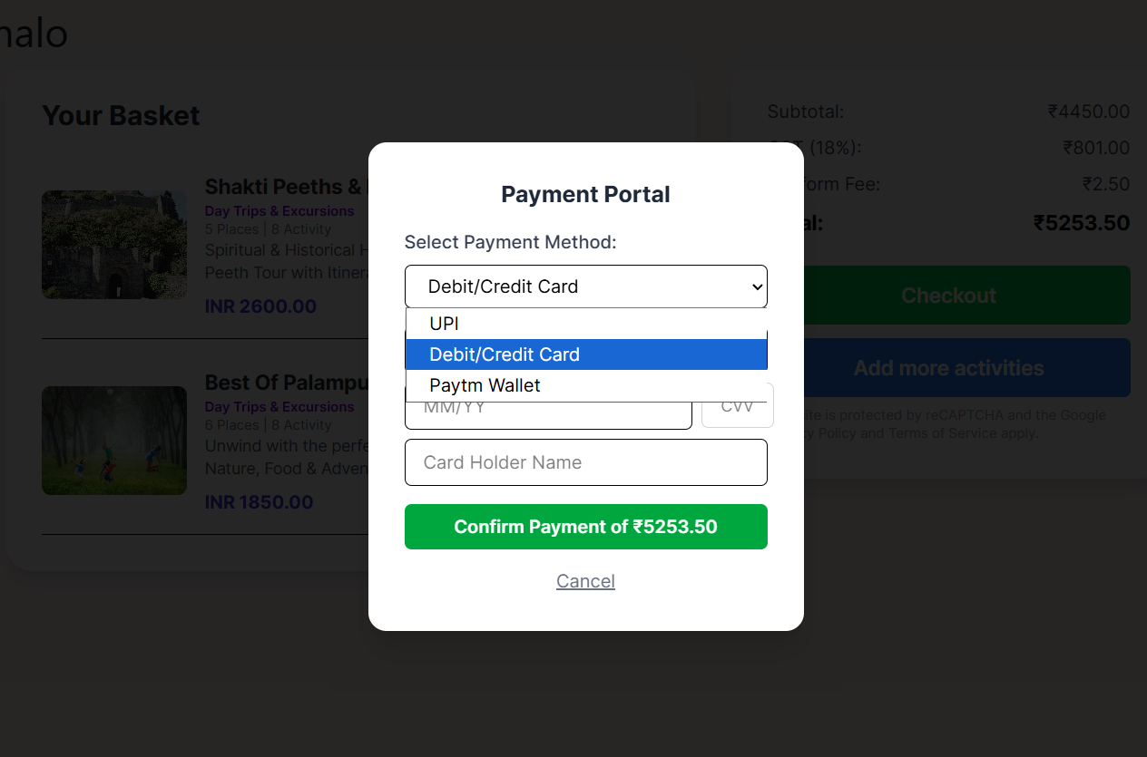

*Fig – 3.7 (Payment gateway linked to Razor pay – Chose your preferred payment method and continue with the process)*

1. Interface for Booking A ride

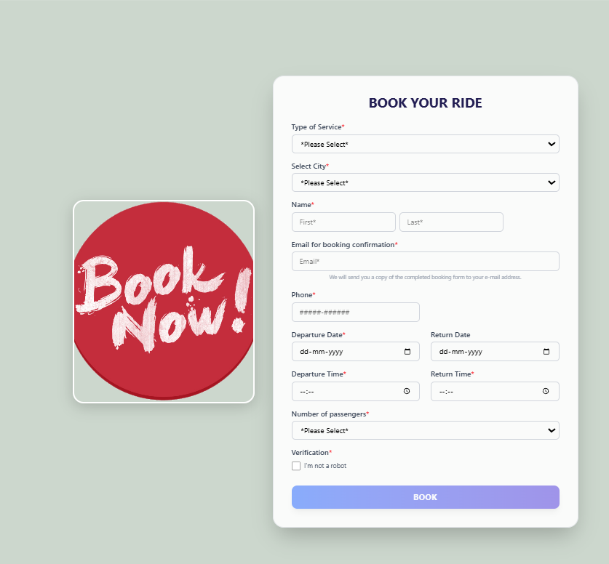

*Fig – 3.8 (Booking Interface – Sends a email to the user on booking confirmation)*

1. AI Chatbot Floating Interface

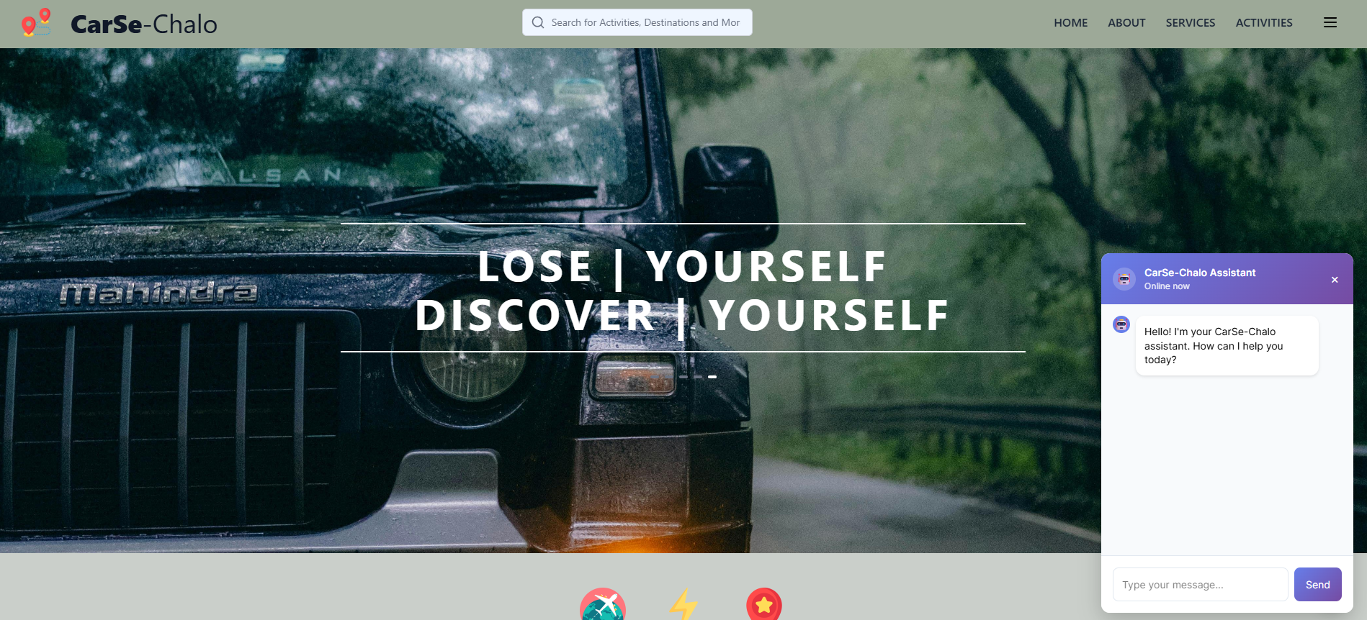

*Fig – 3.9 (AI chatbot for queries and assistance)*

* 1. **Challenges Faced and Solutions**

|  |  |
| --- | --- |
| **Challenge** | **Solution** |
| Preserving cart data across sessions | Implemented useEffect() with Local-Storage syncing |
| Smooth animation without affecting layout | Optimized Framer Motion configurations and transition properties |
| Maintaining user session without backend | Used secure Local-Storage and conditional rendering based on session flags |
| Responsive UI for all devices | Extensively tested Tailwind classes with custom media queries |
| Chatbot response relevance | Trained on categorized travel-related prompts and built fallback logic |

*Table - 3.2 (challenges faced during development and solution to each problem)*

* 1. **Contribution to the Organization**

1. Delivered a complete frontend prototype aligned with Celebal Technologies’ focus on AI and user-centric applications.
2. Proposed a scalable design model for integrating future backend modules like booking engines or payment APIs.
3. Demonstrated the ability to independently manage a modular project life cycle—from planning to deployment-ready code.
4. Documented the project for future enhancements or team collaboration.
   1. **Future Scope of the Project**
5. Full Backend Integration: With Node.js, Express, and MongoDB or Firebase for real-time data handling
6. Payment Gateway Integration: Razorpay, Stripe, or UPI payment processing
7. Live Chatbot Upgrade: Using OpenAI or Dialog flow for natural language support
8. Admin Panel: For managing destinations, users, and bookings
9. User Feedback System: Ratings, reviews, and customer support tickets
10. Multi-language & Accessibility Features: To make it globally accessible and inclusive

**CHAPTER 4**

**LEARNING OUTCOMES**

* 1. **Technical Skills Gained**

During the internship, I acquired and refined a wide range of technical skills related to modern web development, including:

1. Proficiency in **React with TypeScript** for building scalable and component-based UIs
2. Practical implementation of **Tailwind CSS** for designing responsive layouts and styling efficiency
3. Configuration and optimization of projects using **Vite** as a modern frontend build tool
4. Understanding of **React Router DOM** for managing page-based routing in single-page applications
5. Integration of **Framer Motion** to enhance user engagement through smooth animations
6. Implementation of **client-side storage** using Local-Storage for managing session and cart data
7. Design and structuring of an **AI chatbot** to simulate user interaction with logic-based replies
8. Use of **Git and GitHub** for version control, branching, and collaborative workflow management
   1. **Soft Skills Gained**

The internship also contributed significantly to my personal and professional development:

1. Improved **time management** by adhering to weekly sprint goals and deliverables
2. Enhanced **problem-solving and debugging** skills through real-world UI challenges
3. Developed strong **documentation habits** to support code readability and project handover
4. Strengthened **communication and reporting** skills during project updates and documentation reviews
5. Practiced **adaptability and independence**, especially while handling project modules autonomously
   1. **Industry Exposure**
6. Understood the practical expectations and workflows of a technology-driven company like **Celebal Technologies**
7. Gained insights into **agile development practices**, modular code architecture, and the importance of user-centric design
8. Learned the importance of **performance optimization**, **responsive design**, and **cross-platform testing**
9. Observed how technologies like **AI, cloud solutions, and automation** are strategically integrated into modern business applications
   1. **Gaps Identified in Knowledge**

While I was able to make significant progress during the internship, some gaps were identified that I aim to address moving forward:

1. Lack of hands-on experience in **backend technologies** (e.g., Node.js, Express, or database handling)
2. Need to gain deeper understanding of **API integrations**, authentication protocols (JWT/OAuth), and cloud deployment
3. Limited exposure to **real-time features** such as Web-Sockets, live chats, or push notifications.

**CHAPTER 5**

**CONCLUSION**

The internship at Celebal Technologies has been an immensely valuable and transformative experience. Through the development of the CarSe-Chalo web platform, I was able to bridge the gap between theoretical knowledge and its practical application in a real-world project environment. The project allowed me to explore modern web development technologies, focus on frontend engineering, and understand the fundamentals of full-stack scalability.

The internship not only enhanced my technical expertise in tools like React, Tailwind CSS, Vite, and Framer Motion, but also gave me the opportunity to understand key aspects of user experience, responsive design, state management, and project planning. The integration of a self-trained AI chatbot was a particularly significant milestone, as it demonstrated the growing impact of intelligent interfaces in modern applications.

Working on the CarSe-Chalo project exposed me to industry-aligned workflows such as modular component development, Agile sprint planning, and the use of Git for version control. I gained firsthand insight into how enterprise-level software solutions are designed, structured, and tested to meet usability and performance standards.

Furthermore, this internship helped me develop essential soft skills such as time management, independent problem-solving, and technical documentation. It also highlighted areas for future growth—especially in backend development, API integrations, and cloud deployment—which I now plan to pursue in greater depth.

In conclusion, this internship has laid a solid foundation for my professional journey as a software developer. It has broadened my understanding of real-world application development and reinforced my confidence in contributing meaningfully to future technology-driven projects.

**REFERENCES**

**• Framer B.V. *Framer Motion Documentation***. A production-ready animation library for React. [Framer Motion](https://framermotion.framer.website/?)

**• Tailwind Labs. *Tailwind CSS Documentation*.** Utility-first CSS framework for modern UI design. [tailwindcss.com](https://tailwindcss.com/?)

**• *Tailwind CSS Tutorial*. Geeks-for-Geeks.** Utility classes and responsive design examples. [GeeksforGeeks](https://www.geeksforgeeks.org/tailwind-css/?)

**• *React + TypeScript Resources*.** Reddit discussion in r/reacts, referencing best practices and tutorials. [Reddit](https://www.reddit.com/r/reactjs/comments/br01yf?utm_source=chatgpt.com)

**• *Tailwind adoption and experience*.** Reddit r/tailwindcss discussion sharing real-world developer feedback. [Reddit](https://www.reddit.com/r/tailwindcss/comments/njvavc?utm_source=chatgpt.com)

• ***Adventures Overland Private Limited*** – An Indian tour operator specializing in curated and cross-border self-drive road trips integrating travel and vehicle logistics [Wikipedia+1](https://en.wikipedia.org/wiki/Adventures_Overland?utm_source=chatgpt.com)

• ***Bharat Taxi*** – Offers affordable road‑trip packages and car rentals with dynamic booking across India, akin to CarSe‑Chalo’s package listings [Bharat Taxi](https://www.bharattaxi.com/road-trip?utm_source=chatgpt.com)

• ***STIC Travel Group*** – Travel and car rental brand aggregator offering B2B booking portals and destination packages, similar to your custom package features [STIC Travel](https://www.stictravel.com/?srsltid=AfmBOoqRKiMq_IiqFiO0ZYI2LN9qfHUzxKhBaZiQGcAsmqhMN_x_lqAW&utm_source=chatgpt.com)

• ***TravelHouseIndia.com*** – One-stop travel portal offering integrated booking of flights, hotels, packages, and car rentals through a unified interface [travelhouseindia.com](https://travelhouseindia.com/?utm_source=chatgpt.com)